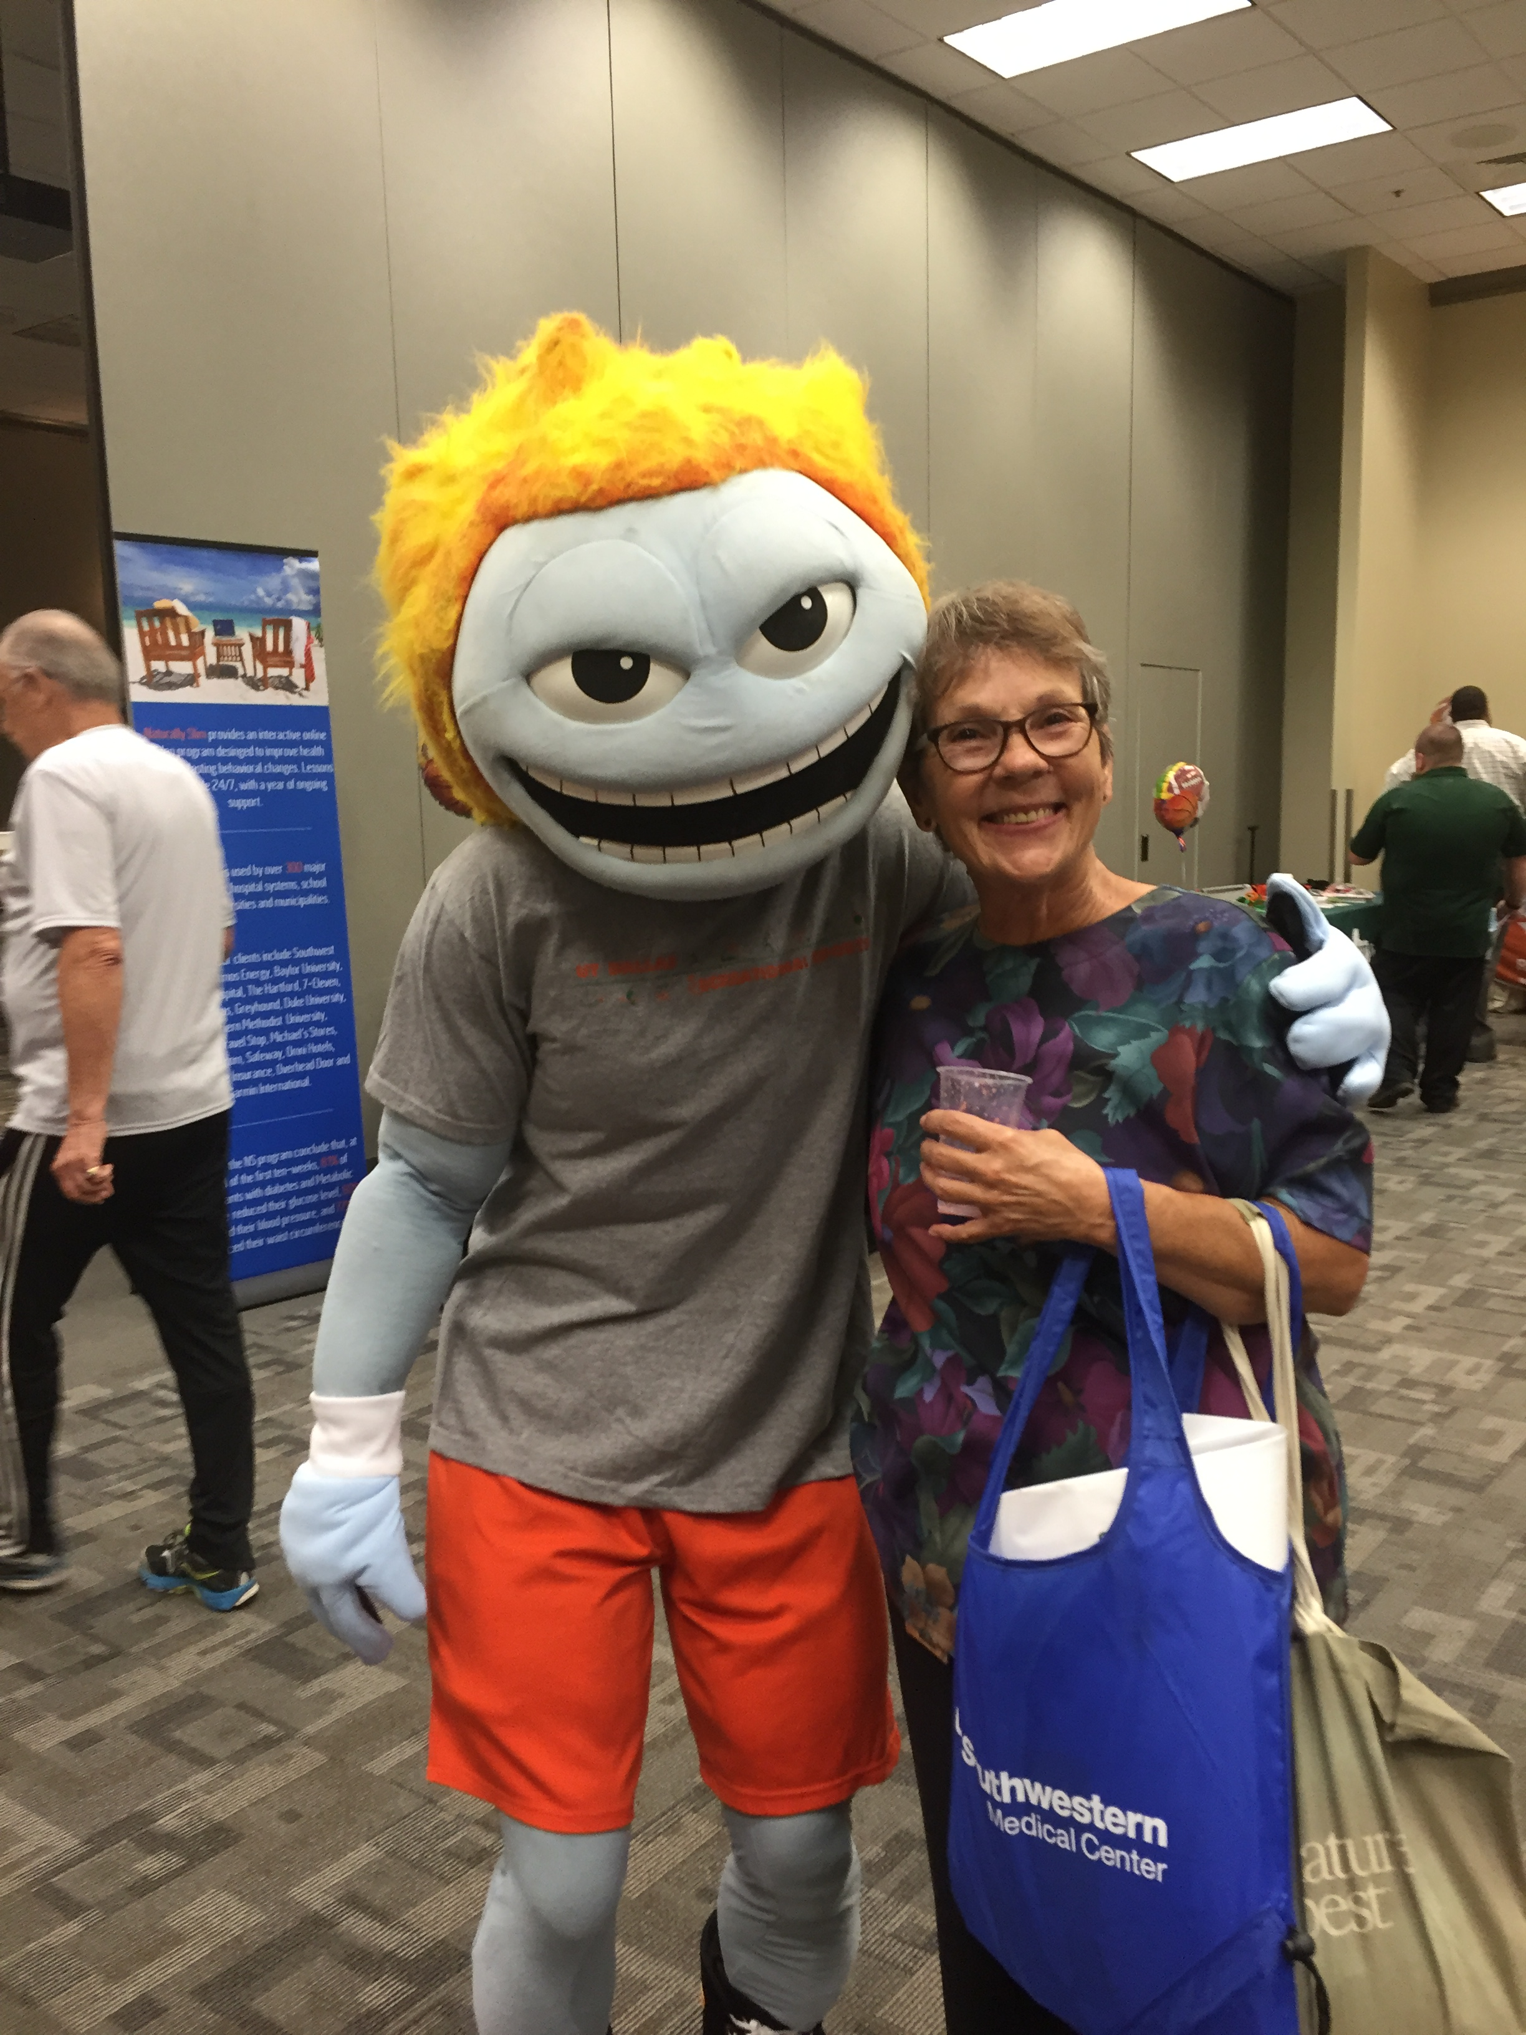

Temoc & Vickie Lincoln, Administrative Assistant for UTD Cleanroom Research Lab enjoy the Benefit Fair on July 18
