GOOD PRIVATE CLOUD-BASED SYSTEM ARCHITECTURES:
A GOAL-ORIENTED SIMULATION APPROACH
Lawrence Chung¹, Tom Hill¹, Owolabi Legunsen¹, Zhenzhou Sun¹, Sam Supakkul²
¹Department of Computer Science, The University of Texas at Dallas, 800 West Campbell Road, Richardson, TX 75080, USA
¹{chung,tlh019200,ool090020, zxs101020}@utdallas.edu
²{ssupakkul@ieee.org}
Abstract. The fast-growing Cloud Computing paradigm makes it possible to use unprecedented amounts of computing resources, hence the potential for offering better services. However, in coming up with a good architecture – one that is more likely to meet its stakeholders’ goals – it is non-trivial to estimate the performance, cost and scalability among others. In this paper, we present a goal-oriented simulation approach to estimating and predicting how well a cloud-based architecture meets such non-functional requirements (NFRs). In the approach, such stakeholder NFRs are expressed as (soft)goals to be achieved, a number of cloud architectural alternatives are explored (different numbers, types and layouts of computing resources), (possible) workload characteristics are explored/estimated, and simulations are run and results used to iteratively build incrementally better architectural alternatives. We illustrate important aspects of this approach and report on our experimental results, using a real-world smartcard-based public transportation system.
Keywords: Cloud Computing, System Architecture, Goal-Oriented, NFR Framework, Simulation Model, CloudSim, Requirements Engineering
- Introduction
Prospective adopters, both users and providers, of cloud computing [1], [2], and [3] are initially attracted by promises of cost reduction, fast service provision and increased reliability. Early in the investigation process, cloud adopters learn that the quality of future performance, cost and scalability predictions is uncertain at best. It is difficult to estimate performance, cost and scalability without real-world experience in the development or migration of cloud applications.
A key cloud adoption question is, therefore, whether the quality of such estimates can be increased to the point that decision makers feel confident that the cloud will (or will not) meet performance, cost and scalability goals. This paper presents two approaches by which goal-oriented techniques may be used together with cloud computing simulations in evaluating whether proposed cloud-based designs will be good enough. Goal-oriented techniques allow for capturing stakeholder goals and using them in exploring, analyzing and selecting among architectural design alternatives while simulation affords a cheaper and quicker way to investigate different aspects of system designs.
First, we present an approach where goal orientation and simulation activities are carried out in any order with simulation modeling and analysis until good enough designs are obtained. In the second approach, goal-orientation is used to form inputs to a genetic algorithm, NSGA-II [4], which performs multi-objective optimization and outputs a set of designs that are most likely to meet the stated stakeholder goals. We aim to show that the use of these approaches can lead to a more systematic approach for integrating user requirements for cloud-based systems [5], [6] into the architecture design process. We focus on the private cloud deployment model, where one organization owns and operates the datacenter, providing shared access to clients on a pay-as-you-go basis.
Methods for dealing with such non-functional requirements (NFR) have been studied (e.g., [7], [8] and [9]). Also, frameworks like KAOS [10], i* Framework[11] and the NFR Framework [12] have been proposed for dealing with NFRs. NFRs can only be satisficed. “Satisfice” has an ancient origin (circa 1600), as a Scottish variant of “satisfy”. It refers to the notion of being “good enough” and is adopted by the NFR Framework for noting the achievement of non-functional requirements (NFRs), referred to as softgoals, which, for their subjective nature, are usually satisficed rather than satisfied in an absolute sense [12]. The NFR Framework and its construct, Software Interdependency Graph (SIG) is therefore chosen for supporting goal-orientated cloud-based architecture simulation in this paper.
The marriage of goal-orientation and simulation is expected to be highly beneficial but challenging. Some work in this regard include [13], for confirming and reconfirming architectural decisions using simulations, [14], [15] for runtime monitoring and system maintenance, and [16] for simulating and optimizing design decisions in quantitative goal models. Cloud Computing simulation is also increasingly being used, especially for investigating infrastructural level concerns, e.g., [17], [18]. The work presented here borrows from all these in an attempt to create a best-of-class methodology for using goal-orientation together with simulations in the cloud.
In Section 2, we describe the system used for illustration in this paper; introduce key Goal-oriented System engineering concepts and give a summary of related work. Sections 3 and 4 describe the aforementioned approaches and Section 5 concludes with a comparison of both approaches and thoughts on future research directions.
- The Myki System - Running Example and Case Study
The techniques presented in this paper are illustrated using the “myki” [20], a contactless smartcard system that automates and harmonizes public transport (trains, buses and trams) ticketing in Victoria, Australia – home to the largest tram system in the world which might one day be migrated to the cloud as user adoption grows. Fig.1 shows main end-user related activities in the “myki” like adding value to smartcard (Fig.1, Top Up), swiping card to enter a vehicle (Fig.1, Touch On), swiping card to leave vehicle (Fig.1, Touch Off) and the automatic deduction of fares. Others include checking card balance, viewing past transactions, reporting and blocking lost card, getting periodic reports and third party payment transactions to banks. All transactions require real time communication with, and processing in, the data center.
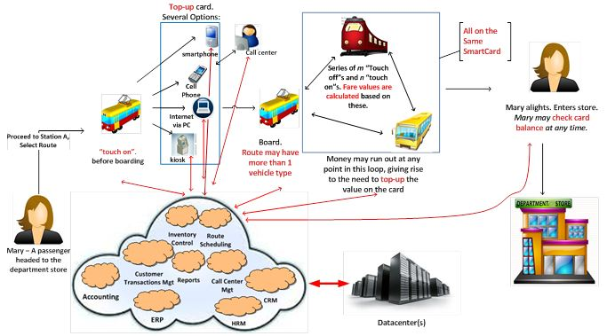
Fig. 1. The “myki” system context diagram showing some essential activities.
We examine the ability of the cloud datacenter to handle different large workloads under different architecture configurations. In addition to the existing workloads that the current system handles, workload variations for two other hypothetical cases are examined: (1) Melbourne earns the right to host the Summer Olympics (2) The Federal government of Australia adopts the “myki” for the whole country. Under these scenarios, architects will need to consider whether the system design can handle large workload variations, beyond what was originally planned for. Questions on whether the system can continue to meet its cost, performance and scalability goals are likely to become more critical. We focus on these goals and show how our approach might be used to derive an architecture that is good enough in the presence of multiple stakeholders, whose goals are also usually incompatible with one another.
Table 1. “myki” Stakeholders and their Goals
Stakeholder | Description | Goals
End-User | Passengers. Pay fares for public transportation. | Quick and convenient request processing.
Cloud Consumer | Intermediaries between Cloud Providers and End-Users | Maintain costs within range of target profit margins.
Cloud Provider | Optional intermediaries who adapt Cloud creator’s infrastructure for the benefit of Cloud Consumers | Good server utilization factor. Right brokering/resource allocation policies.
Cloud Creator | Owns and runs the cloud Datacenter. | Meet SLAs agreed to with Cloud Service Providers.
Table 1 describes the different groups of stakeholders for the “myki” system where stakeholder definition (except “End-User”) follows directly from those proposed in the IBM Cloud Computing Reference Architecture (CCRA) [20]. For the sake of discussion, the stated goals of the stakeholders impose following requirements:
- The “myki” system shall scale to handle the following workloads, measured in terms of requests handled per day (r.p.d): Current (800,000 r.p.d), Peak (3,000,000 r.p.d), Olympic (6,000,000 r.p.d, assuming Melbourne hosts the Summer Olympics) and Australia (16,814,521 r.p.d, assuming Australia adopts the “myki”).
- System performance shall be good enough for all stakeholders if the datacenter can complete all incoming request processing within 12 seconds (typical for POS systems). In the Australia workload, a maximum 30 seconds is acceptable.
- Using a baseline of $100,000,000, an assumed total annual income in the Current workload, the system shall be considered to meet every stakeholder’s cost-related goals if Cloud Computing and Server costs do not exceed 5% of total revenue in the Current, Peak and Olympic Workloads and 50% in the Australia workload.
- Incremental Approach to Goal-Oriented Cloud-Based Architecture Simulation
The main idea here is to narrow the infinite space of possible designs to a small subset by creating a baseline design. Incrementally better versions of this baseline are then iteratively explored through simulation, depending on unmet goals previous iterations, until a design is found that is deemed good enough for all stakeholders. A testbed can then be set up for the final configuration and the entire process repeated, if necessary.
  - A Working Perspective of Private Cloud Computing
Cloud Computing has many diverse definitions of what it means [2], [3]. It therefore becomes important to state our working perspective, which fuels our notion cloud-based system design. Assuming a virtualized datacenter, in our view,
“A (private) cloud consists of a collection of virtual machines running on hosted infrastructure (servers, processors, storage, network) owned by one stakeholder who gives shared access to many customers in other stakeholder groups”
Fig 2 shows the most essential concepts in the “myki” system, a private cloud as well as the simulation model used in the rest of this paper. We propose this as a way to model the three domains, each with its own ontological concepts, which need to be modeled (models of application, private cloud and simulation) in the process of goal-oriented cloud-based architecture simulation. As such the upper part of the diagram has are essential concepts in the real world while the lower part represents things in the simulation environment. Furthermore, both real world and simulation related concepts are subdivided into things in the application domain on the left-hand side and things in the cloud on the right.
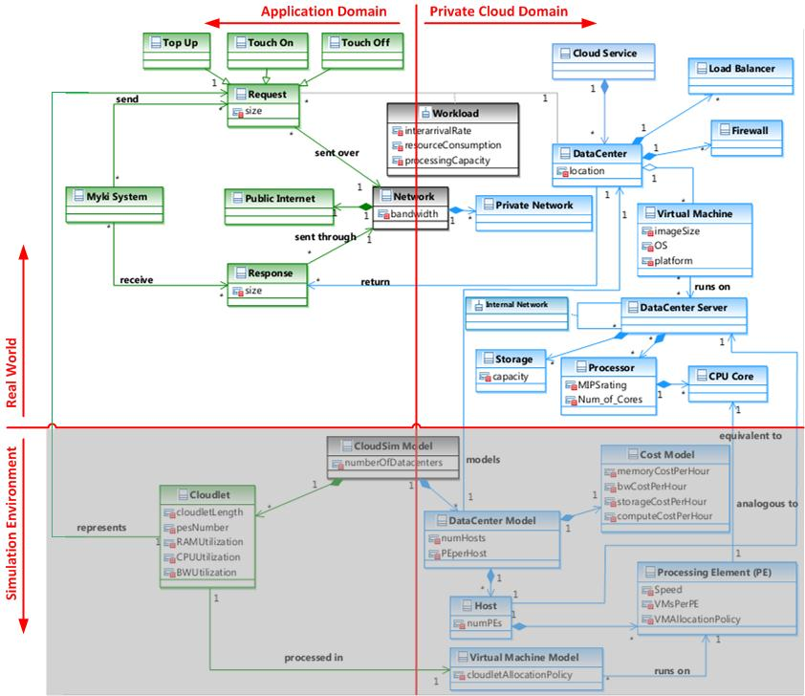
Fig. 2. High-level view of the most essential concepts in the “myki” (left) and our view of a private cloud (right) for the real-world (top) and Simulation environments (bottom)
  - Process Overview
Both approaches presented in this paper follow the 5-step process depicted in Fig 3. The critical difference between both approached is Step 3 in which either a purely human guided incremental approach or a genetic algorithm based approach may be used in finding good candidate designs in the design space.
The 5-steps in the approaches discussed in Sections 3 and 4 are not meant to be followed in strict sequence. Rather, they are envisioned for use in an interleaving and iterative manner whereby aspects of multiple steps may be carried out in parallel while revising outcomes of earlier steps where necessary, depending on new information gained from the later steps. Also, the steps represent a single experimental run that may be iterated until a good enough design is obtained. Step 3 allows selection among architectural alternative either using the incremental approach described in this section or the genetic algorithm based approach described in Section 4.
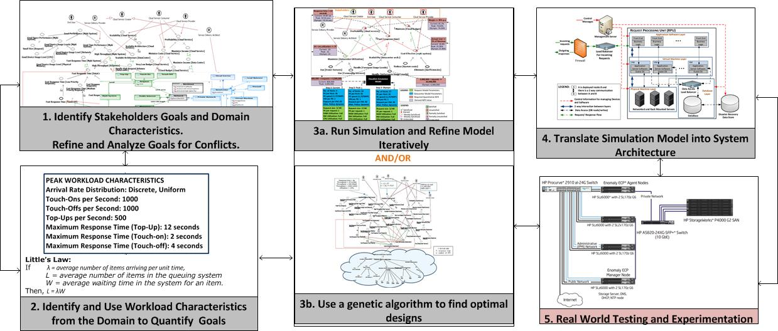
Fig. 3. A summary of our 5-step process.
  - Applying the 5-Step Process to the “myki” Case Study
We proceed to show a stepwise application of the 5-step process to the “myki”:
Step 1 – Stakeholder and Goal Identification plus Goal Refinement and Conflict Analysis: Typically, stakeholder goals are discovered, analyzed and refined during requirements elicitation and techniques for goal-oriented elicitation for cloud-based system development have been proposed, e.g., [5], [6]. Table 1 summarizes the results of such elicitation for the 4 stakeholder groups discussed in Section 2, for the “myki”. SIGs capture the non-functional nature of such goals, represented as softgoals and allow for reasoning about these.
In SIGs, softgoals are shown as clouds with labels - a type and topic. Roughly, the type of a softgoal describes it while its topic (shown in square brackets) tells what it applies to. Softgoals may be refined by AND/OR decompositions. OR decompositions show design alternatives, where achieving one or more alternatives satisfices the parent softgoal. All alternatives in an AND decomposition must be achieved to satisfice the parent softgoal. The bottom leaves in a SIG should ultimately be operationalizing softgoals, represented as thick clouds and which can be actualized by assigned agents in the domain. The SIG is then analyzed in order to identify conflicts and synergies in the goal model. SIGs assist in reasoning about interactions and conflicts among stakeholders goals by depicting the degree of positive or negative contributions among softgoals using pluses (+) and minuses (-). For example, the softgoal, Profitability[cloud service] is “helped” by the softgoal, High Utilization[Datacenter Servers]. This however hurts the goal, Fast Response Time[Datacenter]. This is shown in Fig. 3, which shows the results of this step for the “myki”. We have represented stakeholders as agents (circled stick symbol) and roles (circled R) in the spirit of the i* Framework. We refer to this subsequently as an Agent-SIG diagram. In addition, model refinement has been carried out whereby each high level goal is AND/OR decomposed until specific operationalization is derived.

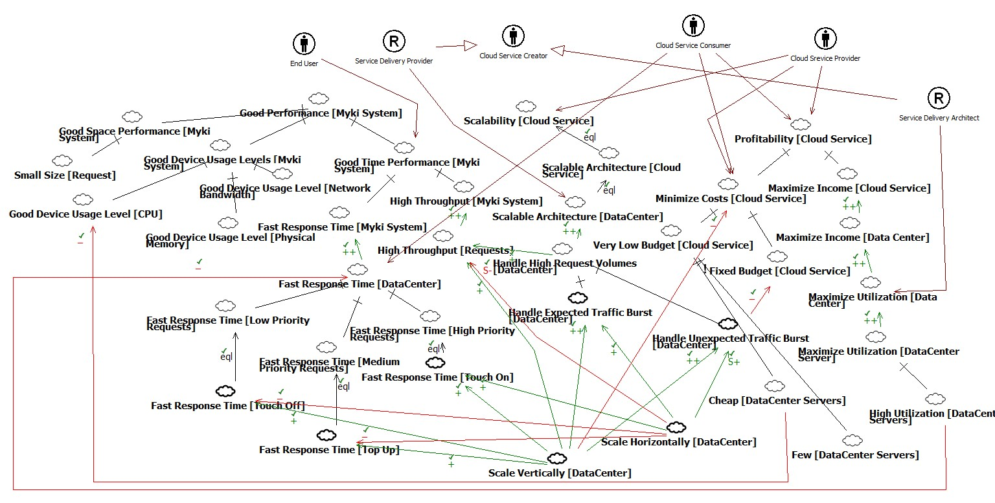
Fig. 4. SIG showing decomposition of high-level “myki” stakeholder goals.
Step 2 – Using Workload Characteristics to Quantify High-Level Goals: To use simulation, which is quantitative, to evaluate qualitative design decisions, the analysis from Step 2 must be augmented with numbers to guide decision making. Thus, stakeholder goals and workload characteristics are quantified as design constraints that the system must satisfy. For the “myki”, given the performance requirements stated in Section 2 and request arrival patterns at the existing datacenter, Little’s Law [21] was used to compute how many requests the datacenter must process simultaneously in order to meet its performance and scalability goals for the different workloads. For instance, the Current workload has a pattern in which about half (300,000) of daily requests arrive during Melbourne’s morning rush hour (2.5 hours). A simple application of Little’s Law then yielded 2500 as the average number of requests that the datacenter must process simultaneously if the 12 second response time is to be met.
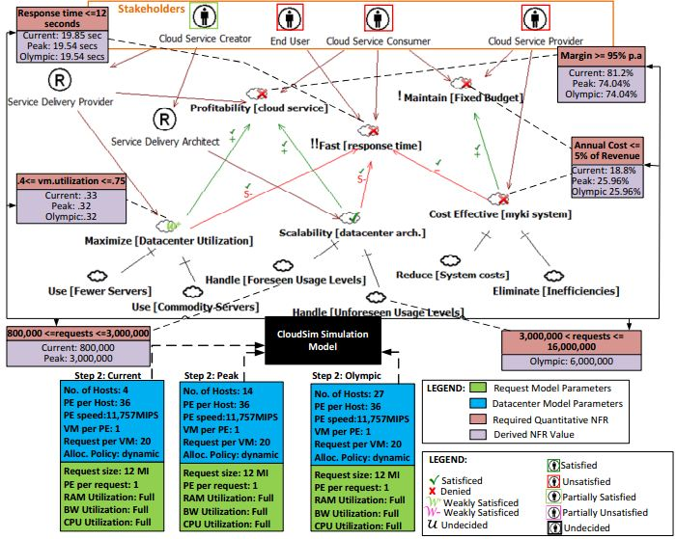
Fig. 5. Visual Notation for evaluating impact of design decisions on degree of goal satisfaction
Step 3a - Simulation and Model Refinement: The aim here is to translate the constraints from Step 3 into a simulation models which serves as a proxy for the actual cloud-based system. This model is then used to investigate the impact of design decisions on the satisficing of goals within the goal model (SIG).
In this paper, we build the cloud simulation model using CloudSim whose authors state in [22] that, “The core hardware infrastructure services related to the Clouds are modeled in the simulator by a Datacenter component for handling service requests. These requests are application elements sandboxed within VMs, which need to be allocated a share of processing power on Datacenter’s host components. By VM processing, we mean a set of operations related to VM life cycle: provisioning of a host to a VM, VM creation, VM destruction, and VM migration”
Thus, simulation modeling in CloudSim is essentially an activity in deciding the parameters of a suitable virtualized datacenter, such as the pattern and size of requests arriving in the datacenter – represented as Cloudlet objects – and the number and capacity of server CPU, VMs, bandwidth among others – represented as Datacenter objects. Initial parameter selection, modeling and simulation model refinement steps for our experiments using CloudSim are briefly highlighted below:
- Modeling Application Requests as Cloudlets: The cloudletLength attribute of a cloudlet represents the number of CPU instructions in, Million Instructions (MI), it consumes. It is difficult to reliably approximate this low-level machine and software implementation dependent variable without writing or deploying any code. For our experiments, we have obtained this value by dividing MIPS rating of current “myki” servers by the estimated number of requests processed per using time at the current server utilization. This yields 2.95, 7.01 and 11.07 MI at the minimum, average and maximum request arrival periods, and these are rounded up.
- Modeling the Cloud Datacenter: In the “myki” system requests are processed in a single datacenter. We therefore model the initial cloud data center to be in a single location. Table 2 shows initial data center configuration used for the Current workload. 1-to-1 mapping of VM to CPU core and request to VM have been pessimistically used in coming up with the baseline and will be optimized subsequently.
Table 2. Initial Datacenter Configuration.(Host: a server installation, PE: CPU core.)
Property | Value | Explanation
Number of Datacenters | 1
PEs per host | 36 | Using HP ProLiant BL680c G5 Servers running on Intel Xeon X7460 processor (36 cores).
Number of Hosts | 70 | 70 X 36 = 2520 > 2500, Assuming 1 VM per PE, 1 request per VM.
MIPS per PE | 11,757 MIPS | MIPS of a single core in the Intel Core i7 920 (Quadcore) running at 2.66 GHz.
Storage Cost | $0.0134/GB/hr. | Derived from Microsoft Azure cloud pricing.
Compute Cost | $0.04/hour | Same as storage cost
Bandwidth Cost | $0.00028/GB/hr. | Same as storage cost
- Using Simulation to Evaluate Degree of Goal Satisfaction: To support evaluation of impact of design decisions on goal satisfaction, we introduce the visual notation in Fig. 5, showing in the same diagram, stakeholders, their goals, the proposed system configuration and various workloads that the system is required to support. Also, Fig. 5 represents results of using this notation on the second iteration in our experiments according to the values shown in Table 3.
The notation works as follows:
    - Simulation model configurations are shown at the bottom for different experimental runs, with request-related parameters (in green) and datacenter-related parameters (in blue), stacked.
    - Progression from the simulation model configuration in one experimental run to the next depends follow from design decisions made based on which all stakeholders’ goals were unmet the previous run.
    - Design constraints are linked to the goals they impact on by dashed lines. Exact constraints that must be met in order to meet a goal are shown in red boxes and simulation results are shown in lilac boxes.
    - Normal rules for reasoning about SIGs remain. The design constraints and simulation results are used as a sort of claim softgoal [12] to justify assignment of various degrees of satisfaction to the softgoals.
    - Constraints may be linked to parent goals or to sub-goals.
    - Depending on whether their goals were met, stakeholders in the Agent-SIG portion are surrounded by colored boxes whose meanings are given in the legend of Fig. 5.
- Initial Simulation, Results and Analysis
For the Current, Peak and Olympic workloads, using estimated arrival rates and initial configuration discussed earlier, the first simulation experiment shows a very small, constant processing time and cost per request as shown in Table 3 and Fig 6. For the !!Fast[response times] softgoal alone, this is a good. But, considering other goals, this cannot lead to a fair system for all stakeholders. Annual Cloud Computing costs grow too quickly (cost as percentage of revenue is almost constant) as a 1-to1 VM to request mapping is used (see iteration 1, Table 3 and Requests per minute and VM Usage graph, Fig.6). Steps taken to improve this initial design are discussed next.
Table 3. Simulation results for 3 iterations over the Current, Peak and Olympics workloads for different configurations.
I | Workload | Hosts | VMs | Policy |  | p.time | p.cost | a.p.cost p | a.s.cost | t.a.cost
1 | Current | 70 | 2500 | space |  | 0.14 | 2158.61 | 4,043,766.76 | 1,400,000.00 | 5,443,766.76
 | Peak | 261 | 9375 | space |  | 0.14 | 8306.14 | 15,560,056.15 | 5,220,000.00 | 20,780,056.15
 | Olympics | 521 | 18750 | space |  | 0.14 | 16612.3 | 31,120,112.31 | 10,420,000.00 | 41,540,112.31
2 | Current | 4 | 125 | DW |  | 19.85 | 141.01 | 18,693,518.32 | 80,000.00 | 18,773,518.32
 | Peak | 14 | 469 | DW |  | 19.54 | 738.18 | 97,096,234.02 | 280,000.00 | 97,376,234.02
 | Olympics | 27 | 938 | DW |  | 19.54 | 1476.37 | 194,193,783.39 | 540,000.00 | 194,733,7839
3 | Current | 7 | 250 | time |  | 0.6 | 216.84 | 1,701,061.25 | 140,000.00 | 1,841,061.25
 | Peak | 27 | 938 | space |  | 0.1 | 1021.63 | 1,307,129.33 | 540,000.00 | 1,847,129.33
 | Olympic | 53 | 1875 | time |  | 0.6 | 2048.6 | 16,070,808.36 | 1,060,000.00 | 17,130,808.36

(Abbreviations: I=”Iteration”, Policy = “Cloudlet Allocation Policy”, DW = “Dynamic Workload Allocation Policy”, p.time = “Processing time per request”, p.cost = “processing cost for all RPM”, a.p.cost = “Annual Processing Cost”, a.s.cost = “Annual Server Cost”, t.a.cost = “Total Annual Cost”
- Incremental Model Refinement and Simulation runs until Convergence
Based on the simulation results in the first run, the current configuration, if deployed, is not likely to result in a fair system from the viewpoint of all stakeholders. To improve, new architectural decisions will need to be based on insights from the initial results and currently unmet stakeholder goals. Some decisions we made to improve the initial design for the Current workload include:
- The initial design for the Current workload suggests having 2,500 VMs, each having its own front-end, business logic and database. A more realistic scenario might use a central database, have the VMs communicate with it via a load balancer and use a second database server for failover.
- The baseline design used a queue length of 1. To improve utilization, we let VMs handle more requests threads.
- The size of each VM is reviewed downwards and different allocation policies are experimented with, including the space-shared and time-shared policies for both cloudlets and VMs. These policies are described in [22]
- The above improvements make it possible to reduce the number of servers used in subsequent iterations.

Step 4 - Translating Derived Model into System Architecture: Results from the simulation process are translated into private cloud architecture in the application domain. The simulations in Step 4 helped narrow down the design space from infinitely many designs to a more useful subset, represented by the parameters of the simulation model in the final step. Although there can still be many designs in this subset, there are techniques and criteria for selecting among architectural alternatives such as those discussed in [23 - 25]. This is out of the scope of this paper so we simply show one possible design and discuss how it may be improved on in real-world applications. We limit our discussion here to the fact that the Service Delivery Architect will have to optimize the datacenter architecture for other design goals like security of sensitivity of customers’ sensitive personal information, which were simulated. Other likely bottlenecks in the real-time processing of such large volume of requests are includes the transactional nature of current RDBMS implementations (which makes scalability harder to achieve), compares with the non-transactional nature of the more scalable No-SQL models used in the cloud.
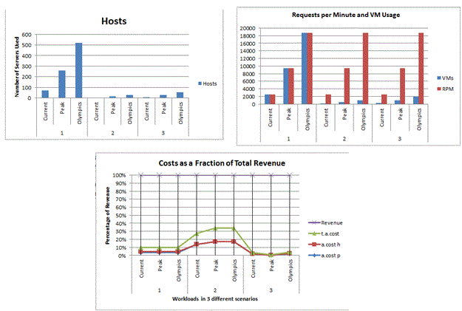
Fig. 6. Graphical view of some of the results in Table 3
These and other constraints have been identified in[50] but cannot be directly simulated in CloudSim. Hence, in the real world, the architect will have to account for these and other goals in the system design while still satisfying the system’s constraints and meeting the goals of all stakeholders. We have not shown what a real architecture might look like in this paper for scarcity of space and also because there is no single unique way to represent this.

Step 5: Testing and Real World Experimentation: Although this is not covered in this paper, mapping from designs obtained from simulation to a real test bed is not likely to be one-to-one. Some reasons for this include NFRs like security and other design considerations which cannot currently be modeled using a cloud simulator. Before buying or provisioning new hardware for this testing, it may therefore be necessary to mitigate costs by first using one of the numerous available virtual test beds such as where possible. Also, in setting up a test bed, [26] provides a set of industry proven reference architectures for different kinds of cloud-based systems and which may a useful starting point and save costs even further. If after setting up the (real or virtual) test beds, the design is found not to match expectations, prior steps in the process might need to be revisited and improved in a new iteration. This is repeated until all stakeholder goals are considered satisficed, perhaps after series of (re)negotiations.
- Genetic Algorithm Based Approach to Goal-Oriented Cloud-Based Architecture Simulation
In this Section, we describe how a genetic-algorithm based approach might be used to come up with a good cloud-based design. With regards to the 5-step process described in Section 3.2, this represents the Step 3b of Fig 3 and the other 4 steps remain the same as explained in Section 3.3.
  - Architecture Selection as a Multi-Objective Optimization Problem
Selecting a single architecture from the huge, if not infinite, space of possible designs in the presence of multiple stakeholder goals, which are often times conflicting, has been described as a multi-objective optimization problem [16]. Genetic Algorithms such as [4] are popularly used to solve such multi-objective optimization problems. While the work in [16] shows one way of using goal-orientation together with a genetic algorithm in system design, we present how such may be applied to cloud-based systems.
The key benefit of using a genetic algorithm for selecting among architectural alternatives is that candidate designs can be automatically evaluated in order to select relatively "optimal" designs from the design space specified. Other practical benefits of using genetic algorithms in this manner include:
  - For each decision point in a goal model, there can be several design options whose selected values have to be aggregated as a single candidate design for the whole system. But there can be a very large number of decision points, each of which may, in turn, have large number of options leading to an explosion in the total number of options which must be specified as parameters to be fed in to the algorithm. Enumerating all such parameters can be very costly or even impossible for some situations.
  - As a result of (a), manual comparisons among architectural alternatives is likely to be along dimensions which may not represent the true ability of each design to meet the stakeholder goals. Thus, locally optimal designs may be selected from the design space.

The genetic algorithm we select for illustration is the non-dominated sorting genetic algorithm, NSGA II [4]. The basic idea of NSGA-II is to combine offspring populations generated from a parent population with another parent population. An optimal population is then selecting the resulting combined population using their non-domination ranks and crowding distances [4] to create next generation and this always preserves elitism.
  - Illustration using the “myki”
There are two key steps to using the NSGA-II algorithm for selection among architectural alternatives.
- Defining Objective Functions: Objective functions used by the algorithm to evaluate and rank all design options and must be defined. Step 2 in the process involves the creation of quantitative bounds for the high-level softgoals. The resulting inequalities can be used to form suitable objective functions. Furthermore, to evaluate the performance of all design candidates quantitatively, we need to create functions for different kinds of performance objectives as shown in Fig. 7.
where μ represents the service rate for one virtual machine, λ is the estimated arrival rate of requests from myki users, and m is the number of virtual machine. To calculate utilization ρ of myki datacenter, we could use
ρ=λ/μ.
Finally, for throughput calculation, we could use
λ = m*ρ*μ.
Calculations for cost are obvious and straightforward. Finally, to evaluate scalability, we simply consider two conditions: Would the response time be affected not at all or only by less than 2%, when the number of users goes up by 100%, Would doubling the number of processors or doubling the speed of CPU reduce the response time by 50%.
- Mapping Design Candidates from SIG to Binary Representation: Basically, for each decision point in SIG in Fig 7, we define the same number of bits as the number of its design options, and for each design option, if it is selected, we assign 1 to the value of the corresponding bit , if not, we assign 0. Then we put these bits together in one order. As an example, for an imaginary Type[Host] decision point in the SIG, if we decide to use HP server1, then the vector should be 1 0 0. And we put all these vectors together as one design candidate in the order of decision points from left to right as they are showed in the SIG in Fig 7. So, for example, [1 0 1 0 0 0 1 0 0 0 1 0 0 1] would represent one design candidate which is one datacenter that has 1200 HP server2s and 200 virtual machine instance located in Burwood, Australia. Further constraints on the selection of design choices, such as exclusive alternatives or mutual dependencies between design options are captured by logical constraints over these bit vectors [16].

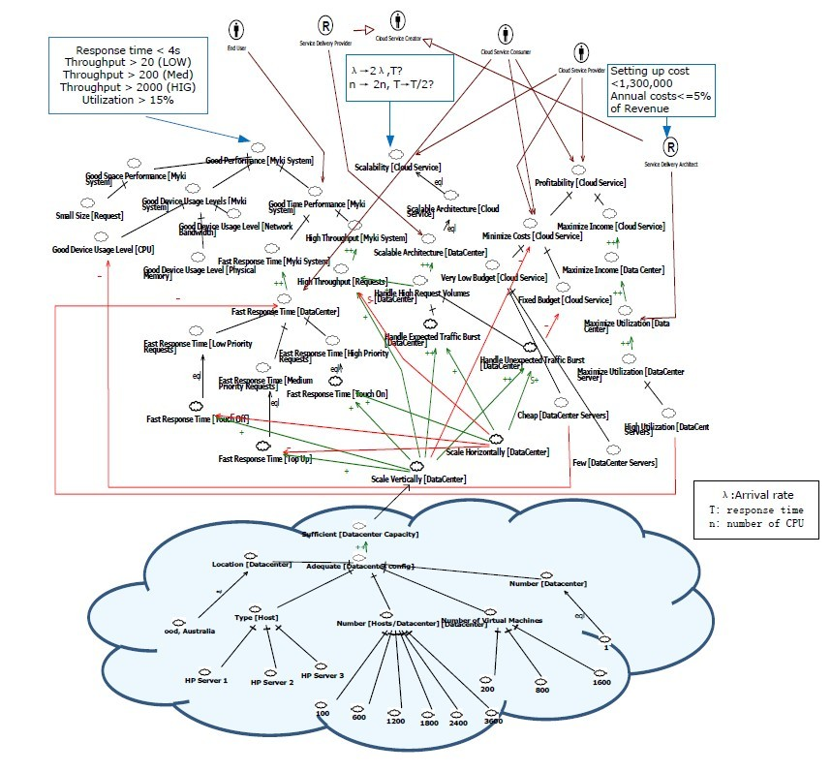
Fig. 7. SIG with objective funtions
For our case, we can model the “myki” as a single station queuing system [29] with many servers. In cloud computing, the requests are processed initially by Virtual Machines, which create an illusion of physical machines for cloud costumers. So here we model these virtual machines as servers and each virtual machine processes the same percentage of incoming requests. The queuing discipline or service strategy determines which job is selected from the queue for processing when a server becomes available [29]. For “myki”, we use the static priorities strategy which means that all kinds of requests, e.g. Touch-on, Touch-off, Top-up are permanently assigned priorities. When selected, the request with the highest priority will be processed first. Within one type of request with same priority, First-Come-First-Serve (FCFS) strategy is used to select the request to process. Based on this performance evaluation on queuing system, we can create formulae to represent our objective functions. For response time, with Little’s theorem and equations from [29], we get mean response time T_{m}, for one server as:
T_{m} = 1 / (μ –λ/m),
- Validating Representational Vectors: Before using crossover or mutation functions in NSGA-II, we need to make sure that each resulting bit vectors actually represent a valid set of design candidates in the SIG. To achieve this, constraints on crossover and mutation functions are specified, such as the constraint that, for each decision point, one and only one design option must be selected.
Having done all these, the NSGA-II algorithm is then run in order to search for the optimal set of design candidates among those specified using such tools as the ATLAB Global Optimization Toolbox which has an implementation of NSGA-II.
- Discussions and Observations
One key technical consideration in this work is whether to use Step 3a or Step 3b during a single run of the 5-step process presented. The former, presented as step 3a in Section 3.3 is iterative and has the benefit of directly utilizing the intuition of human architects in order to incrementally approach better designs on each iteration while the latter, presented in Section 4 can search a very large space of designs and come up with an optimal set. On the flip side, the iterative method may take a long time to converge to a satisfactory solution as the number of iterations is not bounded. The automatic method also has the major downside that the amount of work required prior to running the algorithm may be prohibitive and it does not give as much insight into the selection as the iterative method does and this may be crucial for critical systems. A third option that will be explored in the future is how to use both methods together complementarily.
Although Capacity Planning is expected to be less important in cloud-based systems as it has been for traditional enterprise systems, it can still be a critical success factor in an organization’s Cloud Computing Adoption strategy. To this end, several works on capacity planning for cloud-based systems have appeared (e.g., [27], [28]). However, these have paid little or no consideration to the effect of these techniques can affect the stakeholders of the cloud-based system. This work can help capacity planners to better integrate actual stakeholder needs into their work, considering the conflicts that may exist among such stakeholders and their goals.
One key weakness in both simulation approaches used in this paper is that there are a lot of critical design considerations, such as security and usability which cannot be simulated. Accommodating these during system implementation may have significant negative impact on the predictions made by simulation results.
- Conclusion
The process described in this paper demonstrates one way of exploring, evaluating, and selecting among cloud-based system design alternatives with respect to stakeholder goals. This is likely to provide better rational decision support and even better cost savings for Cloud Computing, which seems to be among the most critical technological innovations for cost savings, while resulting in architectures that are more likely to be good enough despite the unique nature of cloud based system design and conflicts arising from stakeholders and their goals. Using this approach, architects can more rationally and systematically transition from stakeholder goals to the architectural design of a cloud computing-based system. The work also demonstrates the value of goal-oriented – i.e. a rational - approach to the science of design, especially when combined in an interleaving manner with simulation, in understanding and conquering the complexity involved in developing a cloud-based system.
In addition to the Cloud Computing Infrastructure-as-a-Service (IaaS) layer explored in this paper, we are currently looking at how this approach can be applied to other layers in the XaaS model, including the Platform-as-a-Service (PaaS) and Software-as-a-Service (SaaS) layers. In the future we plan to investigate how to make the approach converge much faster to satisficing architecture, while developing guidelines for ensuring that the design in one iteration is better than the ones in the previous iterations. Designs obtained from this approach will be experimentally implemented and tested in a variety of real cloud test beds to see how well the proposed architectures perform, as a way of further validating the approach. Consideration will also be given to better modeling and simulation of performance-related stakeholder activities outside the datacenter which may lead to service degradation if not properly addressed.
References
- M. Armbrust, A. D. Joseph, R. H. Katz, and D. A. Patterson, “Above the Clouds: A Berkeley View of Cloud Computing,” UC Berkeley, Tech. Rep., No. UCB/EECS-2009-28, 2009
- L. M. Vaquero, L. Rodero-Merino, J. Caceres, and M. Lindner, “A break in the clouds: towards a cloud definition,” ACM SIGCOMM Computer Communication Review, vol. 39, no. 1, pp. 50–55, 2008.
- P. Mell and T. Grance, “The NIST Definition of Cloud Computing,” National Institute of Standards and Technology, vol. 53, no. 6, p. 50, 2009.
- K. Deb, A. Pratap, S. Agarwal, and T. Meyarivan, “A fast and elitist multiobjective genetic algorithm: NSGA-II,” IEEE Transactions on Evolutionary Computation, vol. 6, no. 2, pp. 182-197, Apr. 2002.
- R. Clarke, “User Requirements for Cloud Computing Architecture,” in 10th IEEE/ACM International Conference on Cluster, Cloud and Grid Computing, 2010, pp. 625–630.
- S. Zardari and R. Bahsoon, “Cloud adoption: a goal-oriented requirements engineering approach,” in Proceedings of the 2nd International Workshop on Software Engineering for Cloud Computing, SECLOUD’11, 2011, pp. 29-35.
- A. van Lamsweerde, “Goal-oriented requirements engineering: a guided tour,” in Proc. Fifth IEEE International Symposium on Requirements Engineering, 2001, pp. 249-262.
- J. Mylopoulos, L. Chung, and B. Nixon, “Representing and using nonfunctional requirements: A process-oriented approach,” Software Engineering, IEEE Transactions on, vol. 18, no. 6, pp. 483–497, 1992.
- J. Mylopoulos, L. Chung, and E. Yu, “From object-oriented to goal-oriented requirements analysis,” Communications of the ACM, vol. 42, no. 1, pp. 31–37, 1999.
- A. Dardenne and S. Fickas, “Goal-directed concept acquisition in requirements elicitation,” Proceedings of the 6th international workshop on Software Specification and Design, vol. 97403, pp. 14-21, 1991.
- E. Yu, “Modelling strategic relationships for process reengineering,” in Social Modeling for Requirements Engineering, 2011, pp. 1-15.
- Chung, L., Nixon, B., Yu, E., Mylopoulos, J.: Non-Functional Requirements in Software Engineering. Kluwer Academic Publishers, Dordrecht, 2000.
- T. Hill, S. Supakkul, and L. Chung, “Confirming and Reconfirming Architectural Decisions on Scalability: A Goal-Driven Simulation Approach,” in On the Move to Meaningful Internet Systems: OTM 2009 Workshops, 2009, pp. 327–336.
- T. Hill, “Software maintenance and operations hybrid model: An IT services industry architecture simulation model approach,” in Research Challenges in Information Science (RCIS), 2011 Fifth International Conference on, pp. 1–6.
- T. Hill, S. Supakkul, and L. Chung, “Run-time monitoring of system performance: A goal-oriented and system architecture simulation approach,” in Requirements@Run.Time (RE@RunTime), 2010 First International Workshop on, 2010, pp. 31 - 40.
- W. Heaven and E. Letier, “Simulating and optimising design decisions in quantitative goal models,” in 19th IEEE International Requirements Engineering Conference (RE’11), 2011, pp. 79–88.
- A. Kertész, G. Kecskeméti, and I. Brandic, “Autonomic SLA-aware Service Virtualization for Distributed Systems,” in 19th International Euromicro Conference on Parallel, Distributed and Network-Based Processing, 2011, pp. 503–510.
- R. Jeyarani, R. V. Ram, and N. Nagaveni, “Design and Implementation of an Efficient Two-Level Scheduler for Cloud Computing Environment,” 10th IEEE/ACM International Conference on Cluster, Cloud and Grid Computing, pp. 585-586, May 2010.
- “Official Home Page of the myki project.” [Online]. Available: http://www.myki.com.au/. [Accessed: 31-Oct-2011].
- “IBM Cloud Computing Reference Architecture,” 23-Jul-2010. [Online]. Available: https://www.ibm.com/developerworks/mydeveloperworks/blogs/c2028fdc-41fe-4493-8257-33a59069fa04/tags/ccra?lang=en. [Accessed: 08-Mar-2012].
- J. D. C. Little and S. C. Graves, “Little’s Law,” Operations Management, pp. 81-100, 2008.
- R. Buyya, R. Ranjan, and R. N. Calheiros, “Modeling and simulation of scalable Cloud computing environments and the CloudSim toolkit: Challenges and opportunities,” International Conference on High Performance Computing & Simulation, pp. 1-11, 2009.
- R. Kazman, M. Klein, and M. Barbacci, “The architecture tradeoff analysis method,” in Proceedings. Fourth IEEE International Conference on Engineering of Complex Computer Systems (ICECCS ’98), pp. 68 - 78, 1998.
- J. Asundi, R. Kazman and M. Klein, “Using economic considerations to choose among architecture design alternatives,” CMU-SEI, Tech. Report, No. CMU/SEI-2001-TR-035, December 2001.
- L. Chung, B. A. Nixon, and E. Yu, “Using non-functional requirements to systematically select among alternatives in architectural design,” in Proc. 1st Int. Workshop on Architectures for Software Systems, pp. 31–43, 1995.
- “Intel® Cloud Builders Secure and Efficient Cloud Infrastructure.” [Online]. Available: http://www.intel.com/content/www/us/en/cloud-computing/cloud-builders-provide-proven-advice.html. [Accessed: 10-Mar-2012].
- R. Lopes, F. Brasileiro, and P. D. Maciel, “Business-Driven Capacity Planning of a Cloud-Based IT Infrastructure for the Execution Of Web Applications,” in 2010 IEEE International Symposium on Parallel & Distributed Processing, Workshops and Phd Forum (IPDPSW), 2010, pp. 1-10.
- C. Loboz, “Cloud Resource Usage: Extreme Distributions Invalidating Traditional Capacity Planning Models,” in Proceedings of the 2nd international workshop on Scientific cloud computing (ScienceCloud ’11), 2011, pp. 7-14.
- G. Bolch, S. Greiner, H. De Meer, and K. S. Trivedi, “Queueing Networks and Markov Chains: Modeling and Performance Evaluation with Computer Science Applications”. Wiley-Interscience, 1998.

